Motion and Force in a Gravitational Field

Revision Problems 1: Vectors Due: ________________________

Name: ________ ANSWERS _____________ (20 marks)

- Sam is out walking for exercise. He walks 2.50 km South then 3.30 km East.
  - Calculate his displacement. (3 marks)

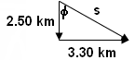
s = 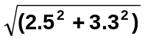 φ = tan⁻¹ (3.3 ÷ 2.5)
= 4.14 km [1 mark] = 52.9⁰ [1 mark]

s = 4.14 x 10³ m S 52.9⁰ E [1 mark]

  - If the walk took 30.0 minutes, calculate his velocity. (2 mark)

t = 30 x 60 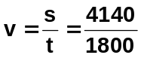 [1 mark]
= 1800 s v = 2.30 ms⁻¹ S 52.9⁰ E [1 mark]

- Jennifer is running laps around the 4.00 x 10² m circular track. She finds on average that it takes her 1.12 minutes to do a lap. Work out Jennifer’s velocity when she is one quarter of the way around the track. (4 marks)
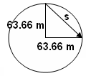
circum = 2πr s = 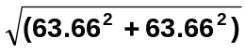
400 = 2πr s = 90.0 m [1 mark]
r = 63.66 m [1 mark]

t = 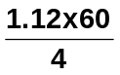 v = 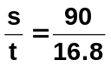
t = 16.8 s [1 mark] v = 5.36 ms⁻¹ [1 mark]

- Ashley throws a 0.200 kg tennis ball against the wall of a house watched by Toby. The ball hits the wall at 5.00 ms⁻¹ East and rebounds with a velocity of 3.50 ms⁻¹ West. Toby determines that the change in velocity took 2.00 x 10⁻² s. Calculate the force of the wall on the ball. (3 marks)

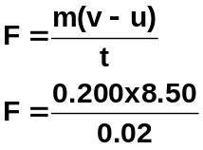m = 0.200 kg
u = 5.00 ms⁻¹ E
v = 3.50 ms⁻¹ W
v-u = 3.5 W – 5 E [1 mark]
= 3.5 W + 5 W
= 8.50 ms⁻¹ W [1 mark]
t = 20 x 10⁻³ s F = 85.0 N West [1 mark]

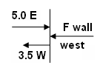
- Lukah is driving her new car at 15.0 ms⁻¹ West when she rounds a corner to be travelling at 11.0 ms⁻¹ North. If the change in velocity took 2.80 s, what was the car’s acceleration around the corner? (4 marks)

u = 15.0 ms⁻¹ W v – u = 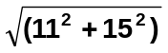
v = 11.0 ms⁻¹ N = 18.6 ms⁻¹
v-u = 11 N – 15 W φ = tan⁻¹ (15 ÷ 11)
= 11 N + 15 E = 53.7⁰
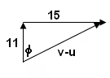
v – u = 18.6 ms⁻¹ N 53.7⁰ E [1 mark]

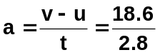 [1 mark]

a = 6.64 ms⁻² N 53.7⁰ E [1 mark]
[1 mark]

- Kristian is flying a model airplane attached to a string. The string is at an angle of 35.0⁰ to the horizontal and has a tension of 69.0 N. Determine the horizontal and vertical components of the tension. (2 marks)
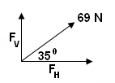
F_{H} = F cos φ
= 69 cos 35
F_{H} = 56.5 N [1 mark]

F_{v} = F sin φ
= 69 sin 35
F_{v} = 39.6 N [1 mark]

- A boy on a bike is free-wheeling down a hill which has a slope of 35.0⁰. The mass of the boy and his bike is 90.0 kg. Assuming no friction, calculate the force accelerating him down the hill.
(2 marks)
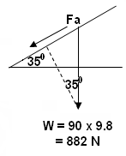

Fa = W sin 35
= 882 sin 35
Fa = 506 N [1 mark]

[1 mark]

